Ideation Phase
Define the Problem Statements
Date | 28-10-2026
Team ID | SWUID2026402568
Project Name | HotelPro - Complete hotel booking and management solution
Maximum Marks | 2 Marks

Customer Problem Statement Template:
To define the core operational and booking problems hotel guests, receptionists, housekeeping staff, and managers face during traditional hotel management workflows, and use those insights to guide the development of HotelPro.

Problem Statement (PS) Matrix:
Problem ID | I am (Customer) | I’m trying to | But | Because | Which makes me feel
PS-1 | Hotel Guest looking for quick lodging | Reserve a room and complete check-in smoothly online | Legacy hotel websites are clunky and show outdated availability | Inventory updates are not synchronized in real time | Frustrated, anxious about double booking, and dissatisfied.
PS-2 | Front Desk Receptionist | Process guest check-ins/outs and print accurate bills quickly | Manual ledger lookup and physical key logs slow down the queue | Lack of a unified digital dashboard connecting front office with rooms | Stressed, overwhelmed during peak hours, and prone to entry errors.
PS-3 | Housekeeping Manager | Track which rooms are dirty, cleaned, or ready for guest check-in | Staff rely on phone calls or paper notes to communicate room status | No real-time status syncing between housekeeping and front office | Confused, delayed in turnover, resulting in guest complaints.

Customer Problem Statement Canvas Diagram:
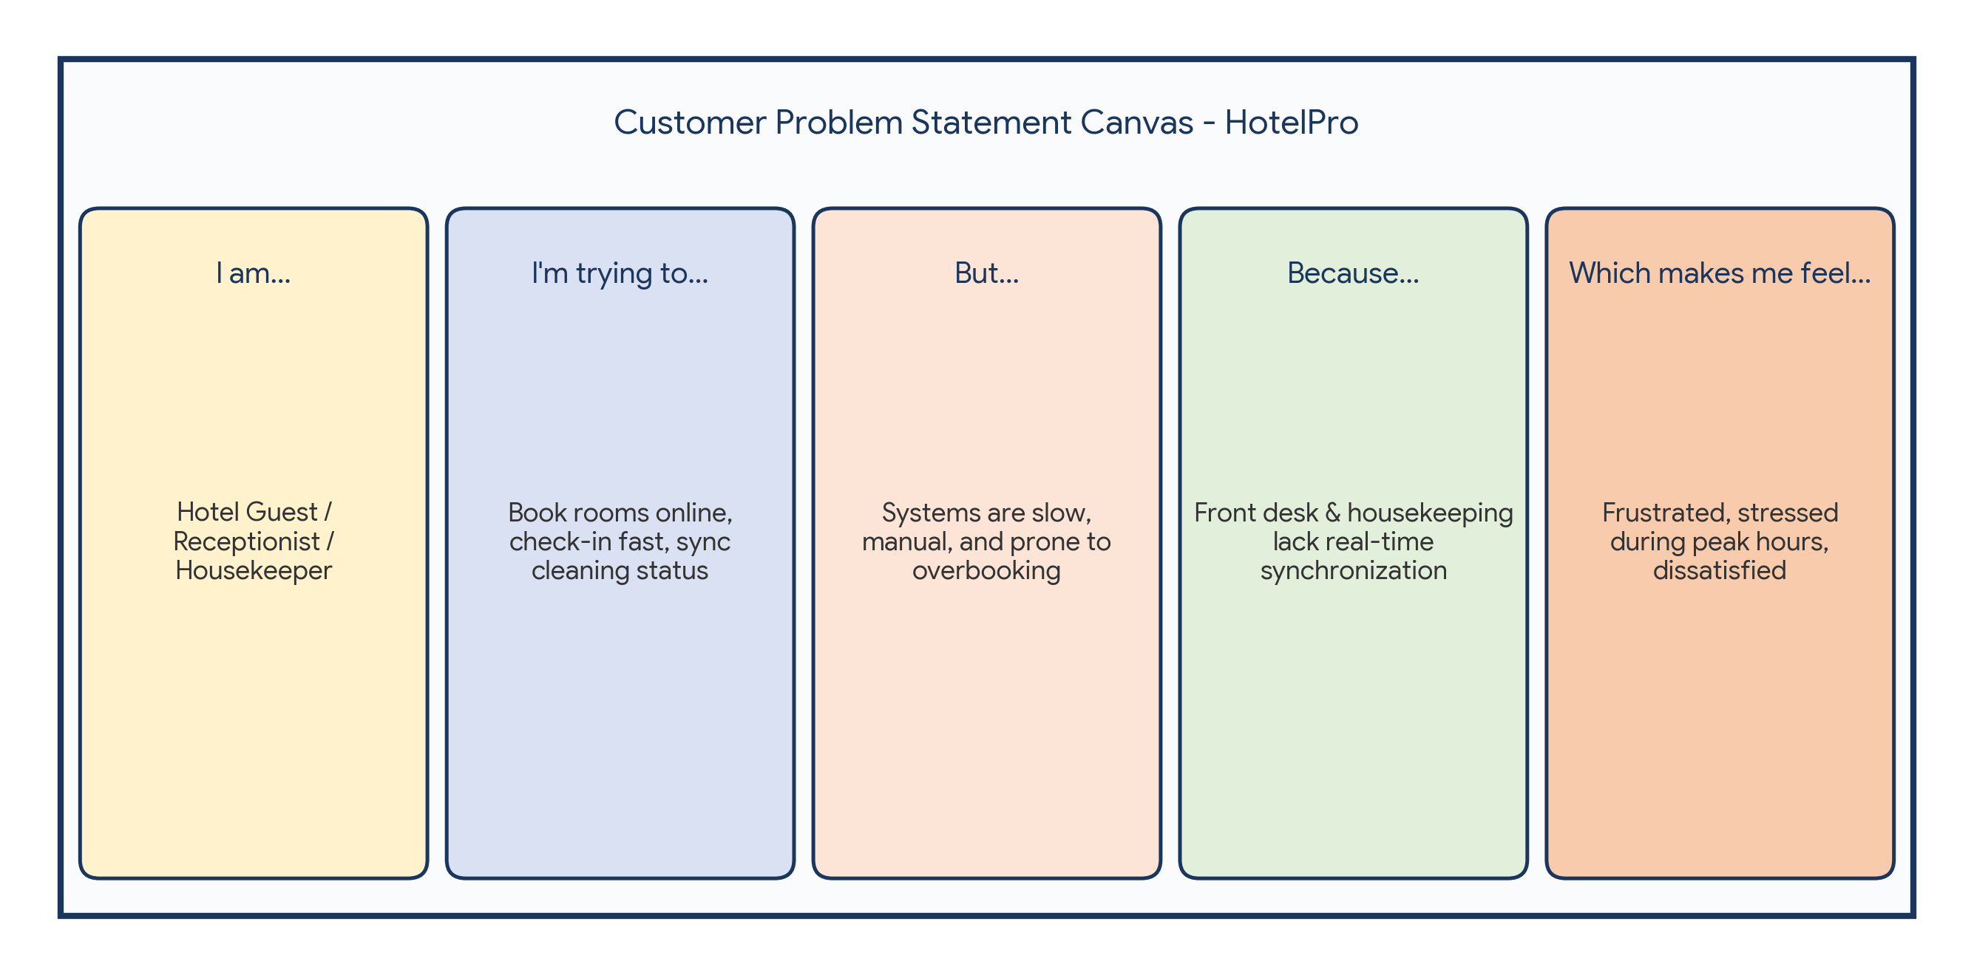
Reference: https://miro.com/templates/customer-problem-statement/

